**LESSON GUIDES FOR TOP CLASS**

**NUMERACY TERM TWO 2020**

**WK I** **ORIENTATION**

**WEEK 2**

**PD 1** **Our numbers**

**Activities**

* Recognition
* Counting
* Writing numbers 1 – 30

0 , 1 , 2 , 3 , …………….

**PD 2** **Numbers**

**Activities**

* Identification
* Reciting / counting
* Writing
* Counting and writing



**PD 3** **Numbers**

**Activities**

* Identifying numbers
* Counting
* 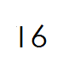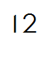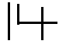Write correctly

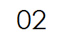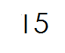

**PD 4** **Numbers**

**Activities**

* Counting
* Write the next number

l l I 5 I 9

I 8 I 2 I 7

**PD 5** **Numbers**

**Activities**

* Recognising
* Counting
* Write the numbers between

l4 l 6 l 7 l 9

l l l 3 9 11

**WEEK 3**

**PD 1** **Numbers**

**Activities**

* Identifying
* Counting
* Join the dots

4 5 6 7

3 2 I 0 8

I 3

I 2 I I I 0 9

I 4

**PD 2** **Numbers**

**Activities**

* Identifying
* Counting
* Writing numbers 1 – 30

1 , 2 , 3 , 4 , 5 , ……………

**PD 3** **Numbers**

**Activities**

* Counting
* Arrange the numbers in order

I , 4 , 0 , 3 , 5 , 2

6 , 7 , I0 , 9 , 8

**PD 4** **Numbers**

**Activities**

* Recognising numbers
* Counting
* Arrange numbers in order

12 , 15 , 11, 13, 14 ,

**PD 5** **Abacus**

**Activities**

* Counting
* Drawing
* 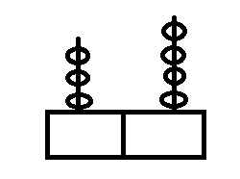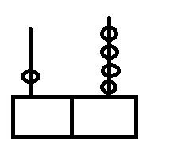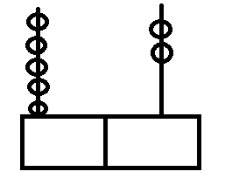Count and write

**WEEK 4**

**PD 1** **Abacus**

**Activities**

* Recognising
* Counting
* Drawing for the abacus

5 3 2 0 8 6

**PD 2** **Number names**

**Activities**

* Copying
* Reading

I I eleven I 4 fourteen I 6 sixteen

I 2 twelve I 5 fifteen I 3 thirteen

**PD 3** **Number names**

**Activities**

* Identifying
* Reading
* Copy and write

17 seventy 19 nineteen

18 eighteen 20 twenty

**PD 4** **Number names**

**Activities**

* Recognising
* Counting
* Matching

11 twelve

12 nineteen

19 eleven

**PD 5** **Number names**

**Activities**

* Counting
* Reading
* Write in figures

sixteen eleven fourteen

twenty eighteen twelve

**WEEK 5**

**PD 1** **Number names**

**Activities**

* Counting
* Reading
* Write in words

I 4 I 2 I I

16 I 7 I 5

**PD 2** **Number names**

**Activities**

* Reading
* Read and draw

two cups four chairs six sticks

ten cups zero cars one house

**PD 3** **Addition**

**Activities**

* Counting
* Drawing
* Adding





**PD 4** **Addition**

**Activities**

* Counting
* Adding

5 + 2 = 0 + 1 = 6 + 4 =

**PD 5** **Addition**

**Activities**

* Counting
* Adding

6 5 0 1

+ 1 + 4 + 0 + 1

**WEEK 6**

**PD 1**

**Activities**

* Recognising
* Counting
* Adding

2 + 1 + 4 = 4 + 6 + 2 =

1 + 1 + 1 =

**PD 2** **Addition**

**Activities**

* Counting
* Adding

4 0 3

2 0 6

+ 5 + 0 + 7

**PD 3** **Addition / word problem**

**Activities**

* Reading
* Counting
* Drawing
* Writing

Add

two + two =

five + two =

three + zero =

**PD 4** **Addition / word problem**

**Activities**

* Reading
* Adding

Six plus one =

Zero plus four =

**PD 5** **Addition / word problem**

**Activities**

* Reading
* Counting
* Writing

Adding

Two plus three equals

Four plus six equals

**WEEK 7**

**PD 1** **Addition / word problem**

**Activities**

* Reading
* Counting
* Adding

Eight add zero makes

One add one makes

Five plus four makes

**PD 2** **Subtraction**

**Activities**

* Counting
* Drawing
* Crossing
* Take away

0 0 - 0 = 0

- = \_\_\_\_\_\_\_\_\_

**PD 3** **Subtraction**

**Activities**

* Counting
* Drawing
* 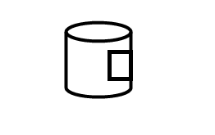Take away



**PD 4** **Take away**

**Activities**

* Counting
* Take away

5 - 3 = 3 - 0 =

4 - 1 =

**PD 5** **Take away**

**Activities**

* Counting
* Subtracting

7 - 4 = 4 - 1 =

8 - 3 = 0 - 0 =

**WEEK 8**

**PD 1** **Take away**

**Activities**

* Counting
* Take away

6 7 6

- 4 - 2 - 0

**PD 2** **Take away**

**Activities**

* Counting
* Take away

9 10 8 4

- 4 - 5 - 7 - 4

**PD 3** **Take away**

**Activities**

* Recognising
* Counting
* Subtracting

Two take away one =

Six take ways four =

**PD 4** **Take away**

**Activities**

* Recognising
* Subtracting

Five take away three equals

Ten take away two equals

**PD 5** **Take away**

**Activities**

* Recognising
* Subtracting

Three take away three equals

Two take away zero equals

Zero take away zero equals

**WEEK 9**

**PD 1** **Time**

**Activities**

* Reading
* Telling the time
* Talking about the things that tell time
* Describing the time of day (night , day , afternoon)

**PD 2** **Time**

* Drawing
* 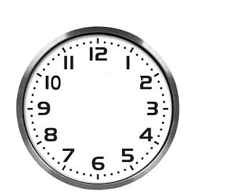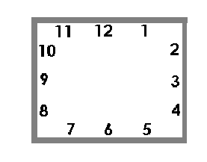Telling the time

3 o’clock 2 o’clock

**PD 3** **Time**

**Activities**

* Drawing
* Telling the time

10 10 o’clock 5 o’clock

**PD 4** **Time**

**Activities**

* Reading the time
* Drawing the clock face
* Showing the time



9 o’clock 8 o’clock

**PD 5** **Comparison**

**Activities**

* Comparing
* Reading
* Learning new words ie many , small , big
* Match

many



small

ANd9GcTnYyx7l6PY-uqGGumXE8ZnGia_YqhCTW--MjRHefQzPT4yc9eBANd9GcTnYyx7l6PY-uqGGumXE8ZnGia_YqhCTW--MjRHefQzPT4yc9eB

ANd9GcTnYyx7l6PY-uqGGumXE8ZnGia_YqhCTW--MjRHefQzPT4yc9eBANd9GcTnYyx7l6PY-uqGGumXE8ZnGia_YqhCTW--MjRHefQzPT4yc9eB big

**WEEK 10**

**PD 1**  **Comparison**

**Activities**

* Comparing objects
* Reading
* Naming
* Vocabulary ( more , much , little)

**PD 2** **Comparison**

**Activities**

* Comparing objects
* Vocabulary (empty , full , half)
* Matching

empty

full

half

**PD 3** **Comparison**

**Activities**

* Comparing
* Reading
* 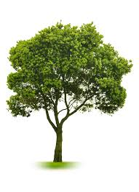Vocabulary ( short , long , tall)



short tall

long